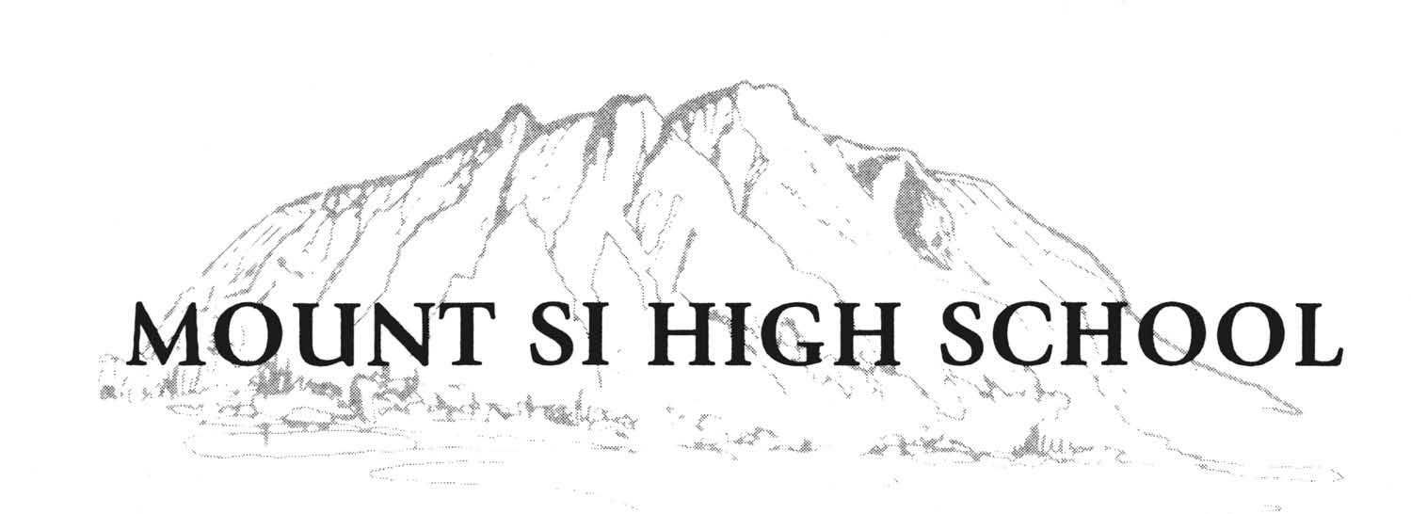
John Belcher, Principal Mount Si High School
Vernie Newell, Associate Principal Freshman Campus
Greg Hart, Associate Principal
Rhonda Schmidt, Assistant Principal
Ray Wilson, Assistant Principal
Jerry Maher, Assistant Principal

Dear parent/guardian and student,

Thank you for your interest in placement of middle school courses on the high school transcript. The district recommends careful consideration regarding placement of middle school grades in the high school transcript. While this can be an opportunity to increase Grade Point Average (GPA) there are consideration that must be taken into account when making the decision to post such grades:

- Courses cannot be removed once placed on the transcript. (WAC 180-51-050)
- A grade lower than an A could negatively impact your child’s overall GPA.
- The state is considering a universal weighted grading system. Placement of this course could negatively impact a weighted GPA, therefore, if you choose to place a middle school grade on your transcript we recommend that you wait until your child’s junior year

Thank you for taking the time to consider these points and please remember that middle school grades can be posted on the transcript at any point during your child’s high school career (RCW 28A.230.090).

Below is a list of middle school courses that can be posted to the high school transcript. Please indicate which course you would like posted:
- Algebra (1 credit) | - MSHS Summer PE (.5 credit)
- Geometry (1 credit) | - Online Summer Health (.5 credit)

I hereby authorize Snoqualmie Valley School District to post the following courses to the high school transcript:

Student Name (Please Print)_________________________________ Student ID#___________
Student Signature __________________________________________ Date __________________

Parent/Guardian Signature ___________________________________ Date _________________

TO BE COMPLETED BY HIGH SCHOOL COUNSELOR:
Counselor Approval: ________________________________________ Date ________________

Middle School: _________________ Course: _________________ Grade: _________________

Middle School: _________________ Course: _________________ Grade: _________________

REV.9/12/2016

